4.4 Algorithm design

4.4.1 YOLO V3

Yolo (you only look once) is an object recognition and location algorithm based on deep neural network. Its biggest characteristic is that it runs fast and can be used in real-time system.

Object recognition and location can be seen as two tasks: to find an area where an object exists in the image, and then identify which object is in the area. In recent years, various methods based on CNN convolutional neural network have been able to achieve good results in object recognition (a picture contains only one object, and basically occupies the whole range of the image). So the main problem to be solved is, where are the objects.

The simplest idea is to traverse all possible positions in the image, search each area with different sizes, different aspect ratios and different positions, detect whether there is an object one by one, and select the result with the highest probability as the output. Obviously, this method is too inefficient.

RCNN creatively proposed the method of region proposals. Firstly, some candidate regions, about 2000 of which may exist objects, were searched from the image, and then the object recognition was carried out for each candidate area. The efficiency of object recognition and location is greatly improved. However, the speed of RCNN is still very slow. It takes about 49 seconds to process an image. Therefore, there are the following fast RCNN and fast RCNN. The neural network structure of RCNN and the algorithm of candidate region are constantly improved. Fast RCNN can achieve the processing speed of about 0.2 seconds for a picture.Although RCNN will find some candidate areas, they are only candidates after all. After recognizing the objects, it is necessary to fine tune the candidate area to make it closer to the real bounding box. This process is called border regression: adjust the candidate bounding box to a more realistic bounding box. Since it is necessary to adjust in the end, why do you have to find the candidate area first? It's about a region range, so Yolo did it.

The picture below shows clearly what the structure is and how it works.

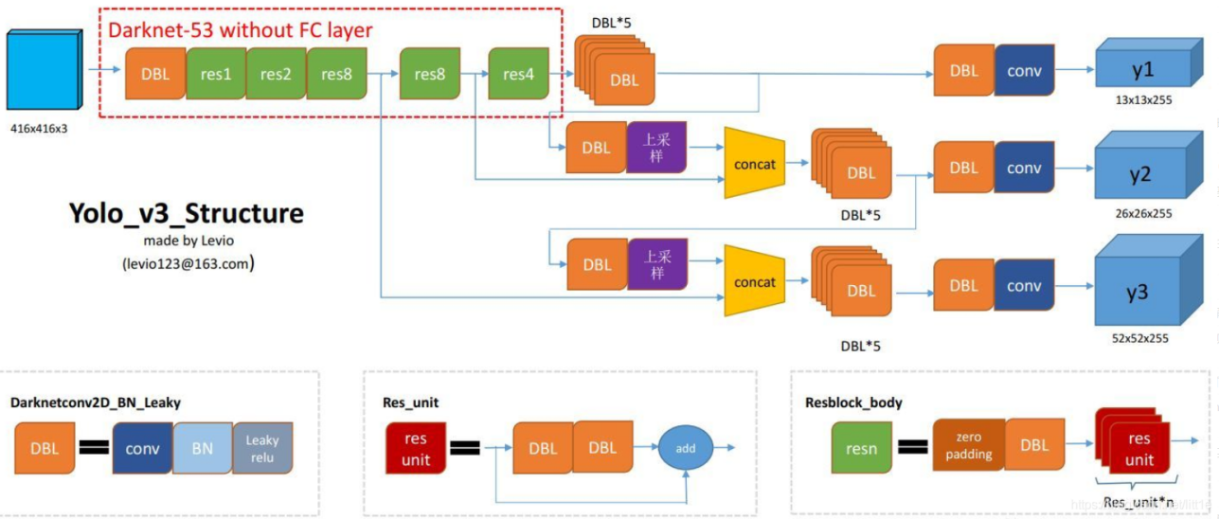

So the core idea of Yolo is to Transform target detection into regression problem solving.Taking the advantages of Yolo into consideration,we choose it to do target detection.

4.4.2 Curve fitting and angle calculation

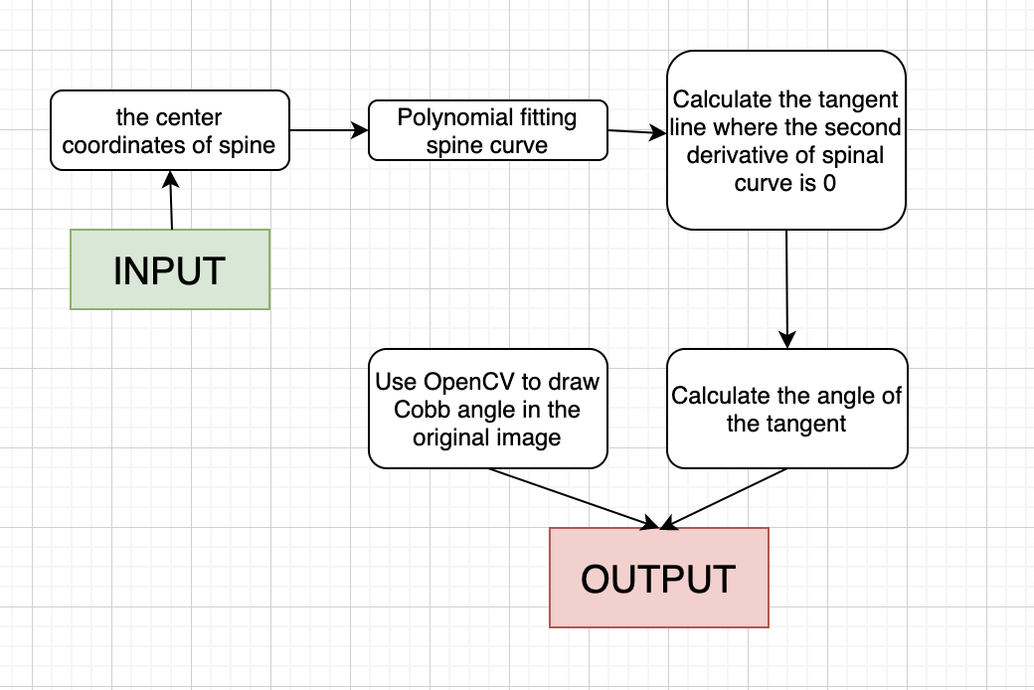

According to the picture above,we get the picture witch has been identified.With the input,we can get the center coordinates of the spine.Then, using these points to get a fitting curve.To find the Cobb angle,we have to find the tangent lines of the curve and use the slope of each line to calculate the Cobb angle.At last,we use OpenCV to draw Cobb angle in the original image and return the result to the server.

Here are some details to calculate the Cobb angle.

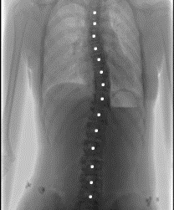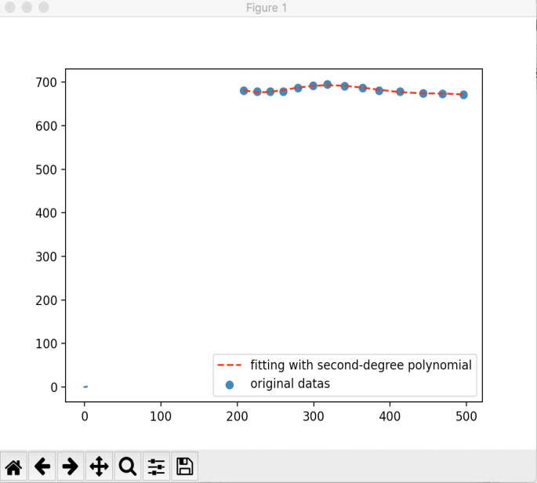

The picture on the left shows the centre points of each bone we have identified.

We’ve tried fifth-degree polynomial, cubic and quartic Bezier curves, and parabolic spline, etc. Finally we choosed fifth-degree polynomial which characterize the spine curve better.

The picture on the right is the curve fitting result chart.

After we get the curves,the next step is to find the end cones.it is also easy to do this.Find the points where the second derivative is 0,and these points in the curve are the end cones.We can calculate the slope of the tangent lines at these points and use the slopes to get the Cobb angle.The picture below shows the process of the calculation.

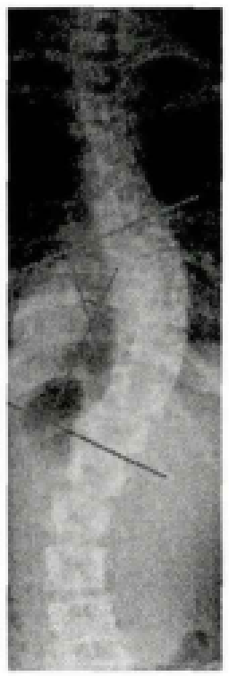 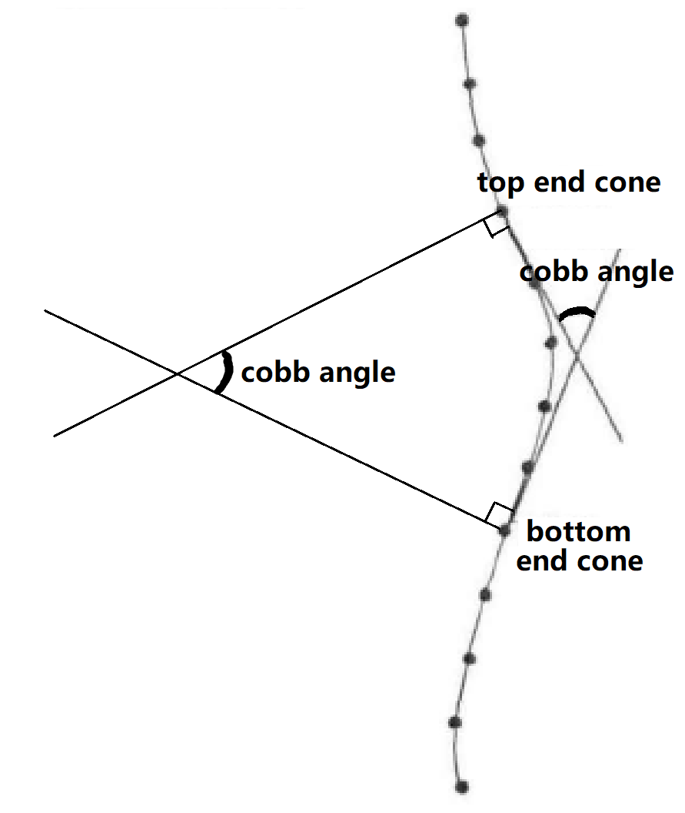

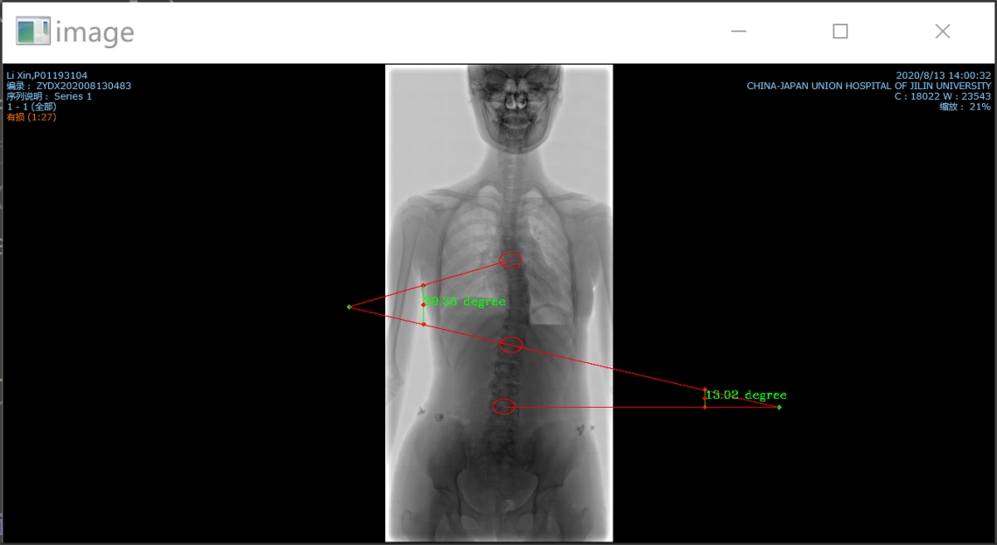

4.4.3 Architecture

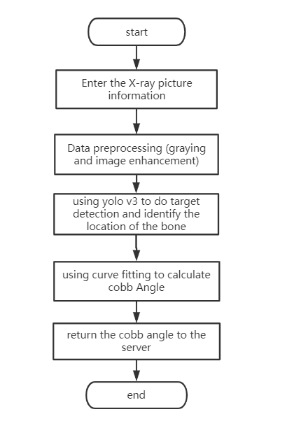

So the main architecture is that the server enter the X-ray picture information and we get the picture.Then we do some data preprocessing such as graying and image enhancement to ensure the accuracy of the target detection.After the pictures have been handled we use yolo v3 to do target detection and identify the location of the bone.With the locations of each bones,we get the fitting curve and calculate the Cobb angles.Finally we return the Cobb angle to the server.

The picture on the right shows the specific process.

4.4.4 Lenke typing

Lenke typing can be divided into the following three steps:

In the first step, six types of scoliosis were determined according to the location of primary and secondary side bends.

Type 1: main thoracic curve, thoracic curve is the main curve, proximal thoracic curve and thoracolumbar curve / lumbar curve are non structural secondary lateral curves;

Type 2: double thoracic curve. The thoracic curve is the main curve, the proximal thoracic curve is the secondary structural curve, and the thoracolumbar curve / lumbar curve is the non structural secondary lateral curve;

Type 3: double main curve, thoracic curve and thoracolumbar / lumbar curve are structural side bending, and proximal thoracic curve is non structural side curve. The Cobb angle of thoracic curve is greater than or equal to that of thoracolumbar curve or the difference between them is no more than 5 degrees;

Type 4: three main curves. The proximal thoracic curve, thoracic curve and thoracolumbar / lumbar curve are all structural side bends. Thoracic curve and thoracolumbar curve / lumbar curve may be the main lateral curve;

Type 5: thoracolumbar curve or lumbar curve. The thoracolumbar curve / lumbar curve is the structural main lateral curve, and the proximal thoracic curve and thoracic curve are both non structural lateral curves;

Type 6: thoracolumbar curve / lumbar curve and thoracic curve. Thoracolumbar / thoracolumbar curve is the main lateral curve, and its angle is at least 5 degree larger than that of thoracic curve. Thoracic curve is a structural secondary lateral curve, and the proximal thoracic curve is a non structural lateral curve.

The table below shows clearly the difference between different types.

|  |  |  |  |  |
| --- | --- | --- | --- | --- |
| Type | Superior thoracic curvature | Main thoracic curve | Thoracolumbar curvature/  Lumbar bending | Side Bend Type |
| 1 | Non structural | Structural(Main bend) | Non structural | Main thoracic bend(MT) |
| 2 | Structural | Structural(Main bend) | Non structural | Double thoracic bend(DT) |
| 3 | Non structural | Structural(Main bend) | Structural | Double main bend(DM) |
| 4 | Structural | Structural(Main bend) | Structural | Triple main bend(TM) |
| 5 | Non structural | Non structural | Structural(Main bend) | Thoracic lumbar bend/Lumbar bend(TL/L) |
| 6 | Non structural | Structural | Structural(Main bend) | Thoracic lumbar bend/Lumbar bend-Structural main thoracic bend() |

In the second step, according to the position relationship between csvl and lumbar curvature, the lumbar curve was further modified into three types: A, B and C.

Type A: csvl passes between the two pedicles of the lumbar vertebrae below the stable vertebrae. If there is any doubt whether the csvl passes through the bilateral pedicle, it will be judged as type B. this type of scoliosis must have thoracic scoliosis with the top vertebra at or above T11 / T12 intervertebral space;

Type B: csvl is located between the lateral boundary of the lumbar concave pedicle and the outer edge of the lumbar vertebral body or intervertebral disc. If there is doubt about whether the csvl contacts the vertebral body or the outer edge of the intervertebral disc, it is determined as type B. This type of scoliosis is also only found in the top of the main thoracic vertebrae, so it does not include thoracolumbar / lumbar scoliosis;

Type C: csvl is located outside the outer edge of lumbar vertebrae or intervertebral disc. The major scoliosis may be located in the thoracic, lumbar and / or thoracolumbar segments. If there is doubt whether csvl contacts the vertebral body or the outer edge of intervertebral disc, it is also determined as type B. Type C may include all major thoracic scoliosis deformities, including all thoracolumbar / lumbar scoliosis.

Third, according to the characteristics of sagittal thoracic kyphosis (t5-12), three correction types of thoracic curvature were determined. If the kyphosis angle of t5-12 is less than 10 ° it is negative (-), 10 ° to 40 ° is normal (n), and greater than 40 ° is positive (+). At this point, the Lenke classification of idiopathic scoliosis has been completed.

In the above steps, we have got the Cobb angle.According to the function of the fitting curve, all the points whose second derivative is equal to 0 are calculated. According to the coordinates of the points, we can find out whether the corresponding spinal position is thoracic or lumbar spine, and identify the specific position of the spine.Thus according to classification basis of lateral bending,we can easily find the Lenke typing..